Civil war in Sierra Leone

UNSC Resolution: | 1389
Date of adoption: | 16 January 2002
Operative paragraph: | 7
Demand number: | 1

Megan MacKenzie

Wording of demand

holding of free and fair elections

List of addressees of the demand

Government of Sierra Leone

Short-term compliance

Description of the addressee(s)’ conduct

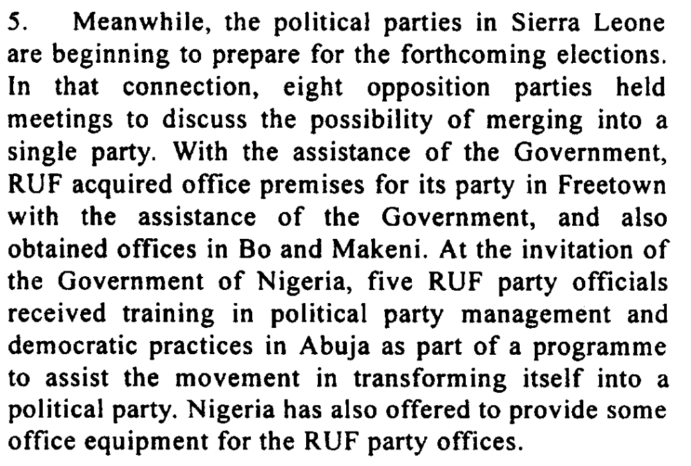

Assessment

Short-term compliance
No or marginal compliance (1) | x Medium low compliance (2) | Medium high compliance (3) | Full or almost full compliance (4)

Considerations underlying the assessment

The elections were not held within this time frame but clear efforts were made to work towards holding the elections.

Medium-term compliance

Description of the addressee(s)’ conduct

The elections were initially scheduled for April 2003 but have already been postponed once and may be again until local government legislation is passed and the debate about the type of elections is settled. It is hoped that elections will be possible in the first half of 2004.

The hard won peace culminated in presidential and parliamentary elections on 10 and 14 May 20021 that were largely without violent incidents but were marred by serious irregularities.

Assessment

Medium-term compliance
No or marginal compliance (1) | Medium low compliance (2) | Medium high compliance (3) | x Full or almost full compliance (4)

Considerations underlying the assessment

Elections were held within this time frame. There were some delays but the demand does not give a specific time frame.

Depth of demand

Assessment

Level of depth of demand
Low depth of demand (1) | x Medium depth of demand (2) | High depth of demand (3)

Considerations underlying the assessment

It was in the interests of the party to hold free and fair elections; however, it required significant mobilization, resources, and coordination. Holding free and fair elections after such a long period of insecurity was a major task.

Level of confidence about coding decisions

Level of confidence about coding decision
Extremely high | x High | Moderate

Comments to IPI (if any)

United Nations Secretary General Twelfth report of the Secretary-General on UNAMSIL13 December 2001
International Crisis Group. Sierra Leone: The State of Security and Governance. ICG Africa Report No 67. Freetown/London/Brussels. 3 September 2003. P18.
International Crisis Group. Sierra Leone After Elections: Politics as Usual? ICG Africa Report No 49. Freetown/London/Brussels. 12 July 2002. P1.

